Crowdfunding Campaign

Background: Crowdfunding is a practice that allows for individuals to receive small amounts of funding from for new projects and business ventures from many people, commonly executed through internet. Several crowdfunding platforms have become popular, and the following datasets are samples that could possibly provide insight on trends that could lead to successful crowdfunding campaigns.

Tables and Figures:

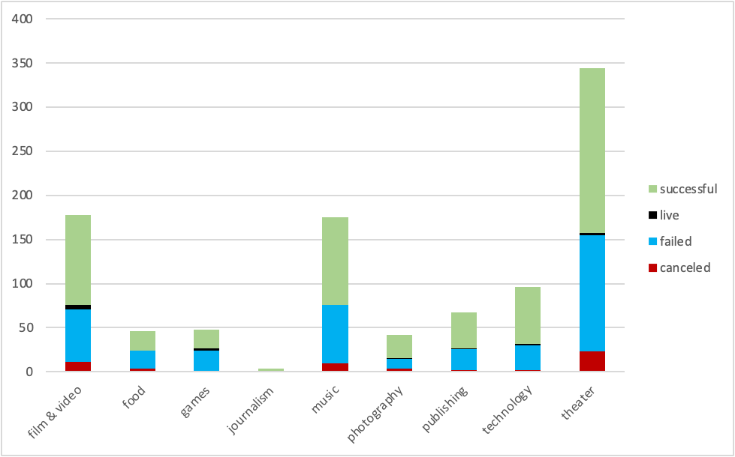
Figure 1. Parent Category Outcomes

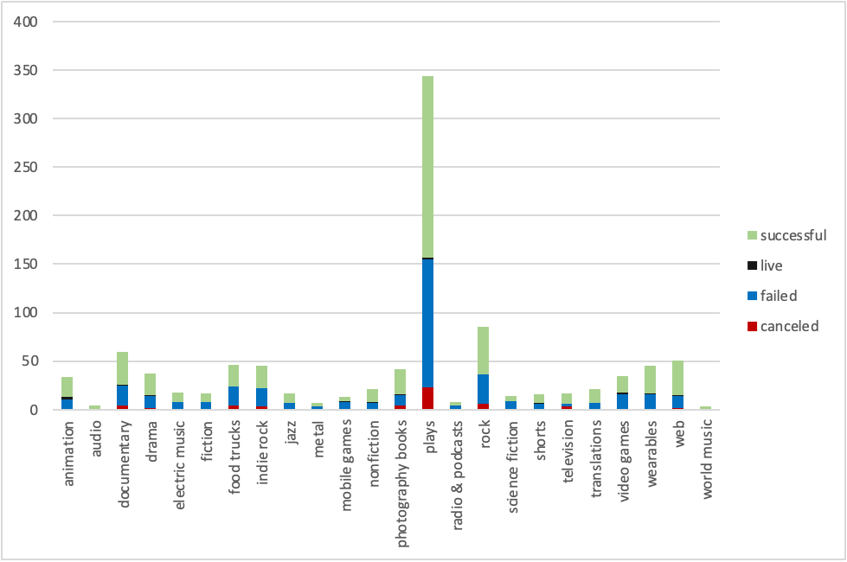
Figure 2. Sub-category Outcomes

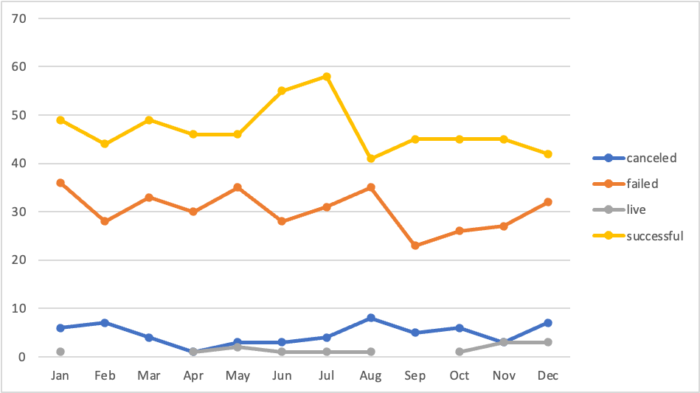
Figure 3. Monthly Outcomes

- Given the provided data, what are three conclusions that we can draw about crowdfunding campaigns?
Based on the provided data, it can be concluded that crowdfunding campaigns are mostly used for theater, film & video, and music projects. Journalism project crowdfunding campaigns have the highest success rate; however, they have the lowest number of total crowdfunding campaigns. It can also be concluded that crowdfunding campaigns are most successful between the months of May and July and are least successful during the month of August. Crowdfunded projects are more likely to succeed than they are to fail as the overall success rate is 56.5% in contrast to the 36.4% failed rate. Based on the sub-categories of projects, it can be concluded that plays are

- What are some limitations of this dataset?
- It is unknown if the dataset provided is from one, single crowdfunding company, or takes several different companies’ data into consideration.
- The dataset provided may be a sample of data and not statistically suggestive of conclusive results.
- What are some other possible tables and/or graphs that we could create, and what additional value would they provide?
Some other tables that we could create would be pivot tables comparing the countries of the respective crowdfunding campaign projects with the failure, success, and canceled rates that would provide insight to assess if a respective country plays a role in the success of the crowdfunding campaign.

Statistical Analysis

Statistical Analysis | Successful Backers | Failed Backers
Mean | 851.15 | 587.51
Median | 201.00 | 114.50
Minimum | 16.00 | 0
Maximum | 7,295.00 | 6,080.00
Variance | 1,603,373.73 | 925,919.32
Standard Deviation | 1,266.24 | 962.25
IQR | 1152 | 751.5

Given the above measures of central tendency, we can conclude that there is more variability with successful campaigns, which is logical being that there are more successful campaigns than failed campaigns. The median should be used to summarize the data, as the data is right skewed because the mean is significantly larger than the median.

